**Project 2 Notes**

1. **Run the trading strategies for each of the assets in the classes (8 dataframes) – Desi (Done)**
2. **Trading Strategies – Desi (Done)**
3. Run through Random Forest Model – Abuzar (Stocks and Commodities) and Saibal (Forex) and Aizhen (Crypto)
4. Run through Artificial Neural Network – Saibal (Crypto and Commodities) and Aizhen (Stocks) and Chris (forex)

**Random Forest and ANN Model**

* I think to be consistent, when we setup the models, lets all us a random_state =42. Not critical, but just so we are all consistent.

**Machine Learning and Trading Strategies – Training and Test Split**

* We have to remember to shift the feature variable before we run our models, otherwise there will be look-ahead bias. Example code below:

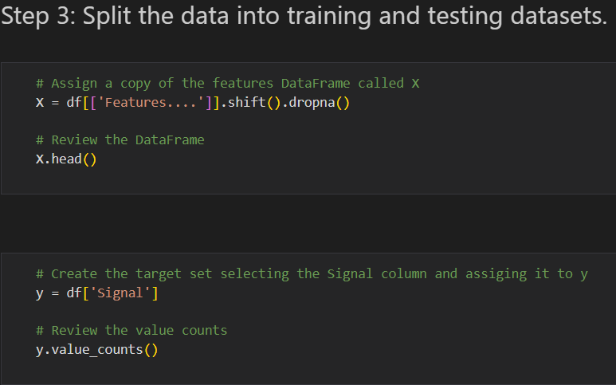

**Splitting Datasets:**

Stocks, Commodities and Forex (use 145 months for training and the rest for testing – Example code below)

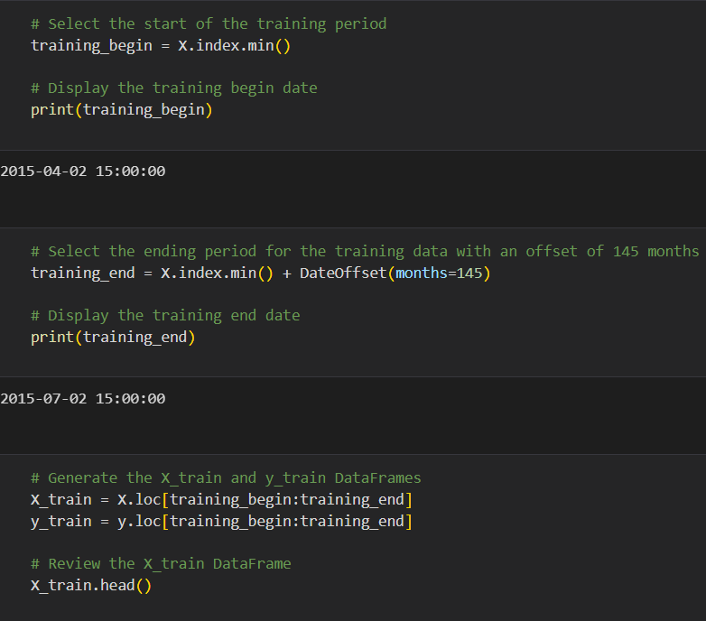

Bitcoin (BTC) - use 70 months for training and the rest for testing – Example code below)

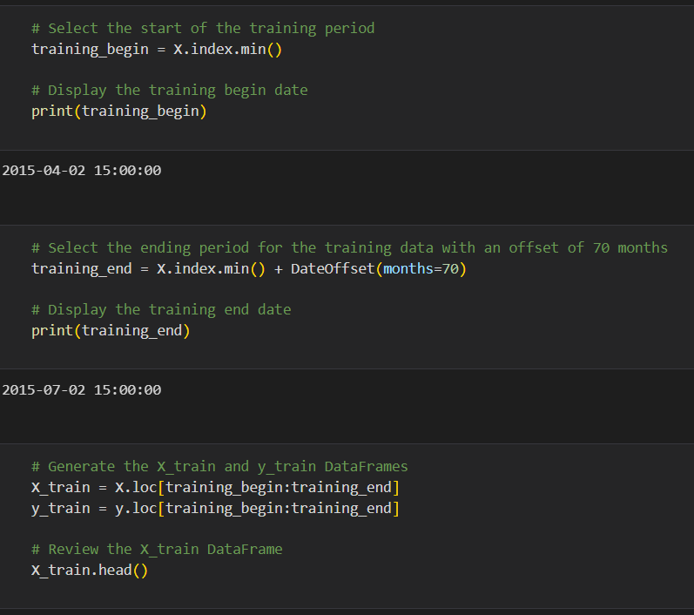

Ethereum (ETH) - use 42 months for training and the rest for testing – Example code below)

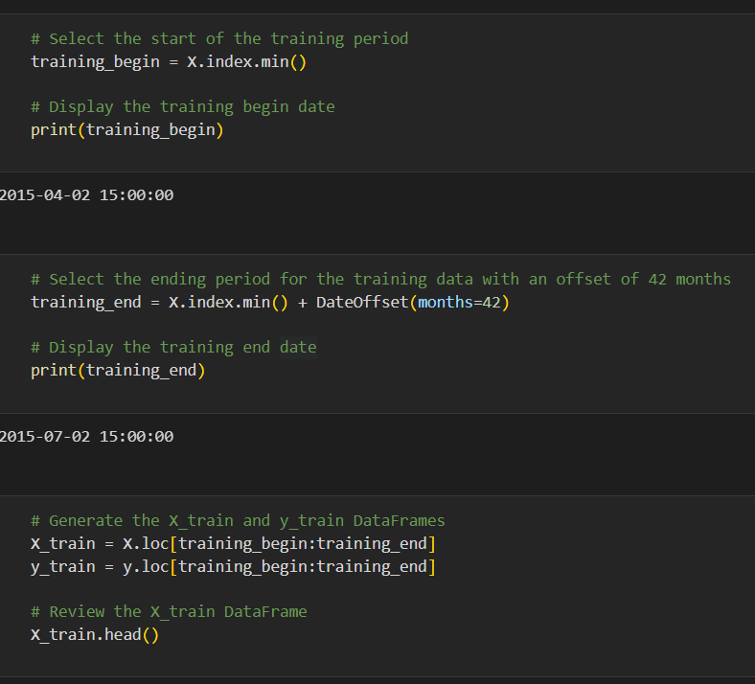

* Lastly below is how, we can setup the test data (code below):

